**RAMCO INSTITUTE OF TECHNOLOGY , RAJAPALAYAM-62611**

**DEPARTMENT OF ELECTRONICS AND COMMUNICATION ENGINEERING**

**IOT ASSIGNMENT**

**TOPIC: Build a smart home in tinkercad use atleast 2 Sensors, Led , Buzzer in a circuit . Simulate in a single code .**

**NAME: ABINAYA.S**

**CODE:**

int trig = 7;  
int echo = 4;  
void setup()  
{  
  pinMode(trig, OUTPUT);  
  pinMode(echo, INPUT);  
  Serial.begin(9600);  
}  
  
void loop()  
{  
  //ultrasonic sensor  
  digitalWrite(trig,LOW);  
  digitalWrite(echo,HIGH);  
  delayMicroseconds(10);  
  digitalWrite(trig,LOW);  
  float dur = pulseIn(echo,HIGH);  
  float dist = (dur*0.0343)/2;  
  Serial.print("distance:");  
  Serial.println(dist);  
   
  //led  
  if(dist>=100)  
  {  
    digitalWrite(13,HIGH);  
  }  
  else  
  {  
    digitalWrite(13,LOW);  
  }  
  //temperature sensor  
  double a=analogRead(A0);  
  double t=(((a/1024)*5)-0.5)*100;  
  Serial.print("Temp Value:");  
  Serial.println(t);  
  delay(1000);  
   
  //led  
  if(t>=100)  
  {  
    digitalWrite(8,HIGH);  
  }  
  else  
  {  
    digitalWrite(8,LOW);  
  }  
  //motion sensor  
  int m=digitalRead(2);  
  Serial.print("motion detected:");  
  Serial.println(m);  
  if(m==1)  
  {  
    Serial.println("yes");  
  }  
  else  
  {  
    Serial.println("no");  
  }  
  //buzzer  
   if(m==1)  
  {  
    digitalWrite(12,HIGH);  
  }  
  else  
  {  
    digitalWrite(12,LOW);  
  }    
}

**SCREENSHOTS:**

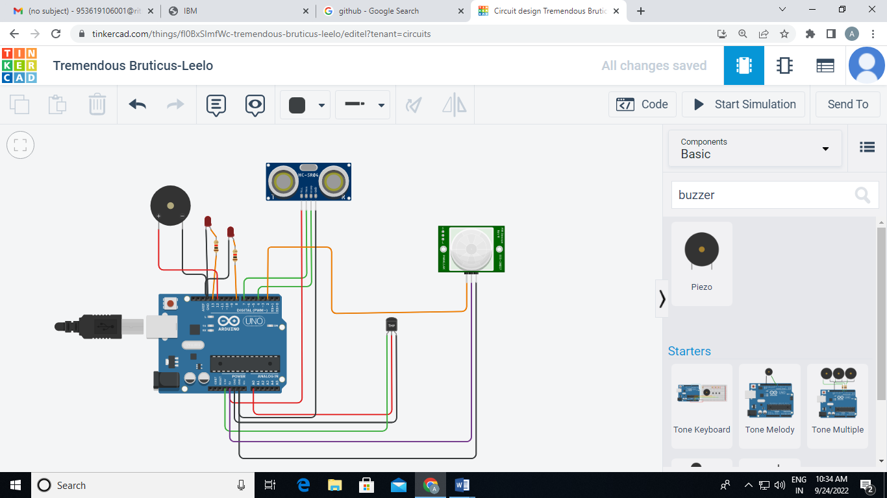

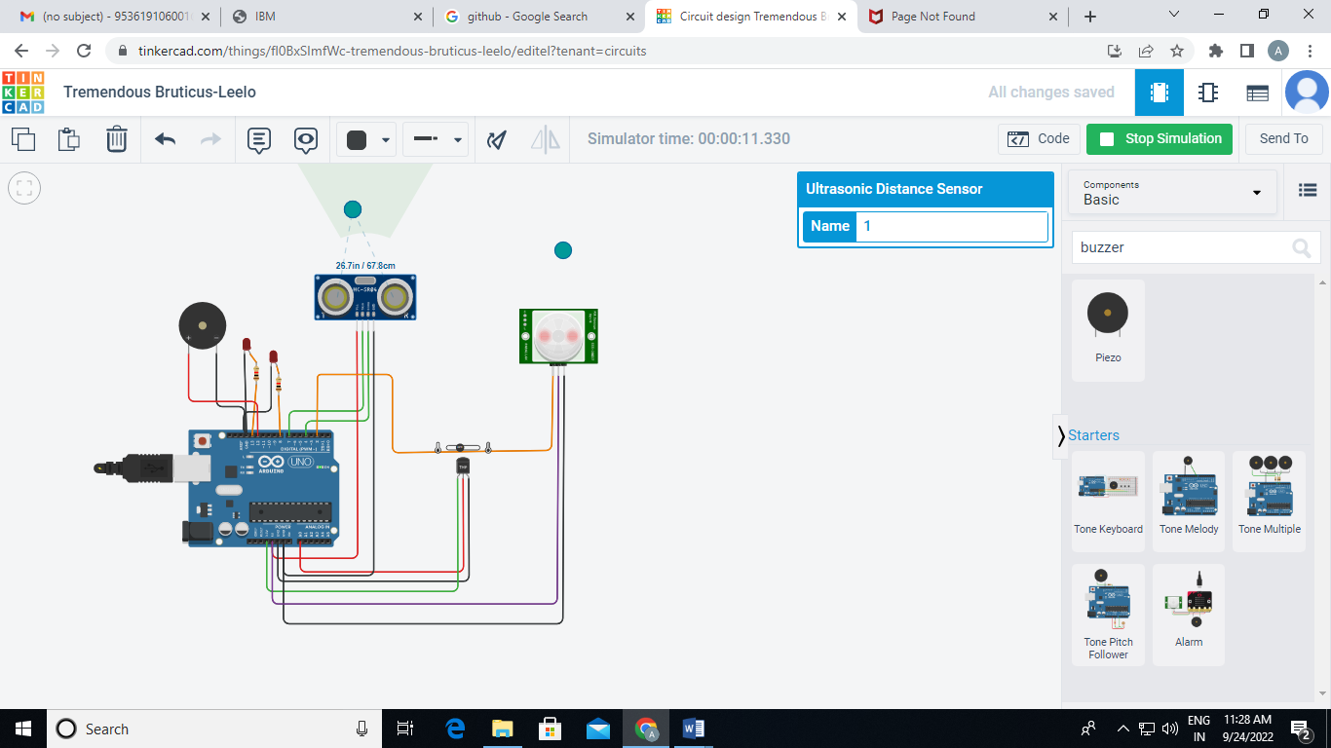

**OUTPUT:**

